DBS LAB 5:
24k-0810
Problem 1: Aggregate Functions
Given: A table Employees with columns:
- emp_id – Employee ID
- emp_name – Employee name
- department_id – Department number
- job_id – Job title ID
- salary – Employee salary
- hire_date – Hiring date
Tasks:
- Write a query to find the total number of employees.
- Write a query to calculate the average salary of all employees.
- Write a query to find the maximum salary in the company.
- Write a query to find the minimum salary in the company.
- Write a query to calculate the total salary paid to all employees.
- Write a query to count employees whose salary is greater than 5000.
- Write a query to calculate the average salary excluding duplicate salary values using DISTINCT.

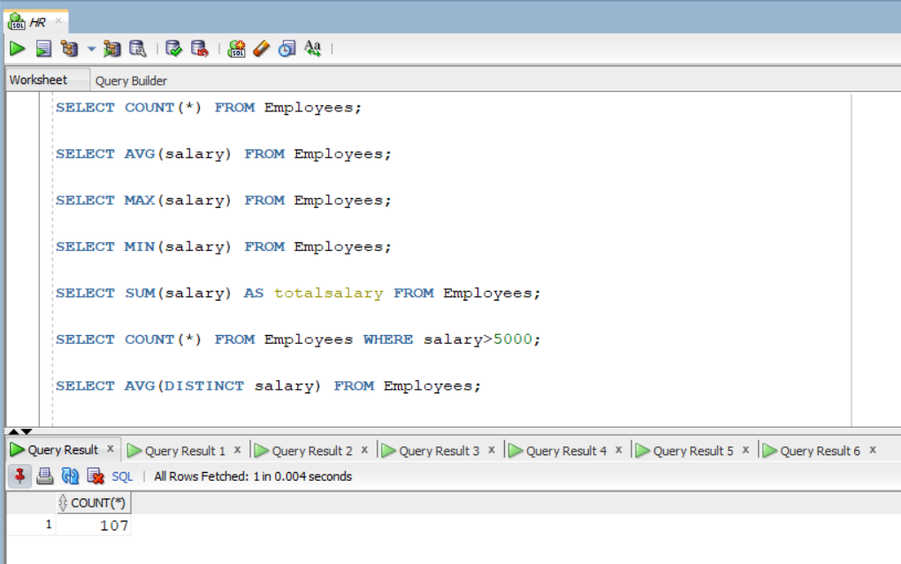
Problem 2: GROUP BY Clause
Given: Use the same Employees table.
Tasks:
- Display the number of employees in each department.
- Display the average salary for each department.
- Display the maximum salary in each department.
- Display the total salary for each department and job_id (use multiple columns in GROUP BY).
- List departments having more than one employee.
- Display departments sorted by total salary in descending order.
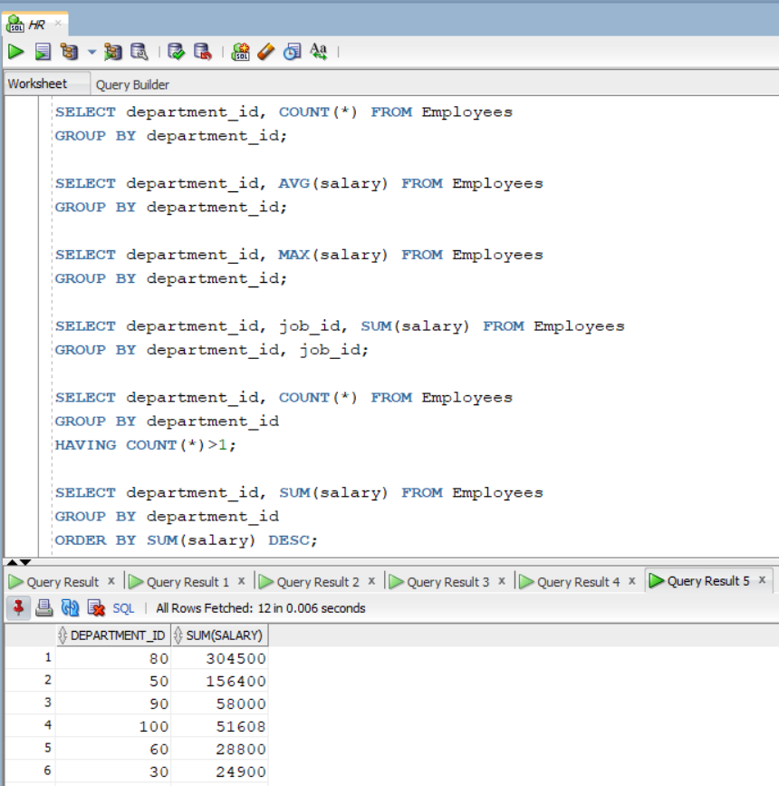
Problem 3: HAVING Clause
Given: Use the same Employees table.
Tasks:
- Show departments where the number of employees is greater than 3.
- Display departments where the average salary is greater than 6000.
- List departments where the maximum salary is greater than 10,000.
- Display job_ids where the total salary is greater than 20,000.
- Show departments having less than 2 employees.
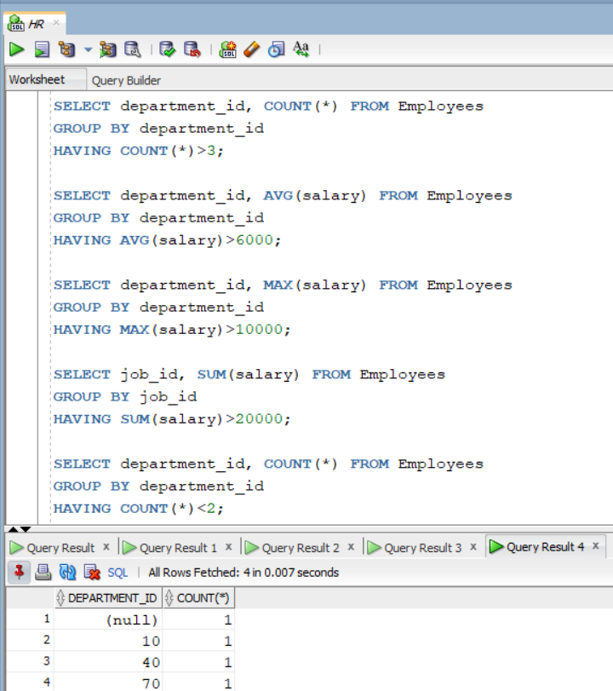
Problem 4: DISTINCT vs GROUP BY
Given: Use the same Employees table.
Tasks:
- Display all distinct department_id values using DISTINCT.
- Display all distinct department_id values using GROUP BY.
- Compare the results of both queries.
- Write a query to display distinct job_ids and count employees in each job.
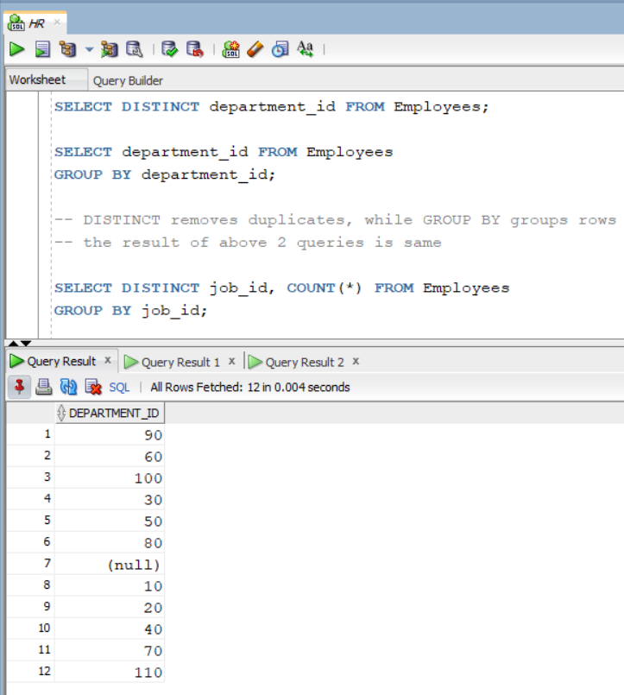
Problem 5: DML — INSERT
Given: A table Tasks with columns:
- task_id – Task ID (Generated by default as identity, Primary Key)
- title – Task title (Unique, Not Null)
- start_date – Task start date
- due_date – Task due date
- priority – Task priority (Default = 3)
- description – Task description
Tasks:
- Insert one record into the Tasks table specifying all columns.
- Insert a record by specifying only title and priority (use DEFAULT for priority).
- Insert multiple records using INSERT ALL.
- Insert records into Tasks using data from the Employees table (use INSERT INTO SELECT).
- Insert a task where:
- task_id = total number of employees
- title = email of employee with emp_id = 'E102'
- priority = total number of employees
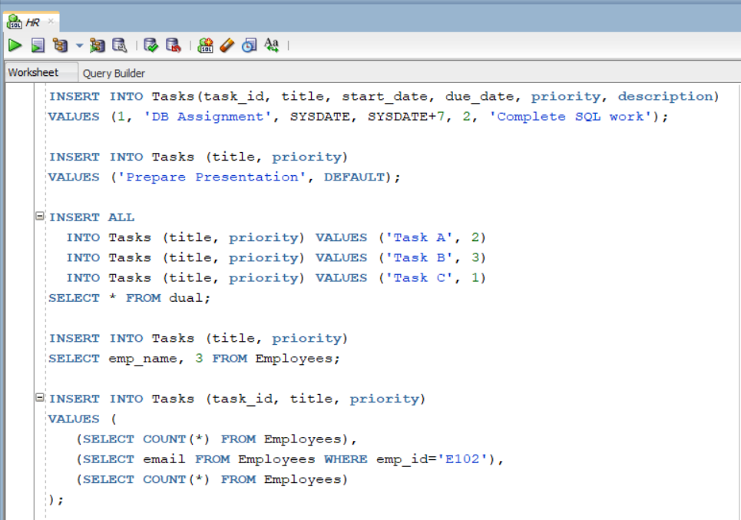
Problem 6: DML — UPDATE
Given: A table Employee with columns:
- empNo – Employee number (Primary Key)
- empName – Employee name
- department – Department name
- email – Email address
- phone – Phone number
Tasks:
- Update the name of employee with empNo = 'E100'.
- Update both department and email for employee E101.
- Replace email domain from @colorado.edu to @nu.edu.pk for employee E102.
- Increase salary of all employees in department 10 by 10%.
- Set priority = 1 for all tasks whose due_date is before today.
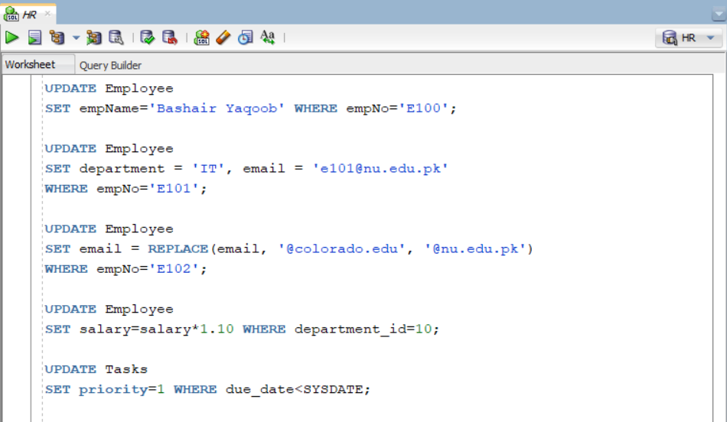
Problem 7: DML — DELETE & TRUNCATE
Given: Use Employee and Tasks tables.
Tasks:
- Delete the employee whose empNo = 'E103'.
- Delete all employees belonging to department ‘HR’.
- Delete tasks where priority is less than 2.
- Remove all records from Employee using DELETE.
- Remove all records using TRUNCATE TABLE.
- Explain the difference between DELETE and TRUNCATE.
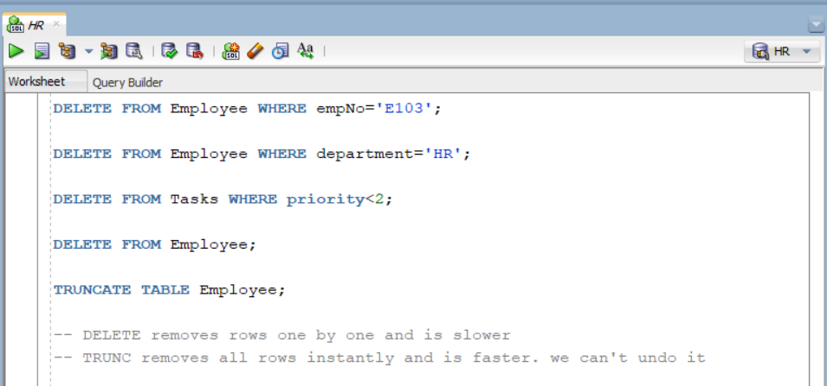
Problem 8: Combined Query
Given: Use the Employees table.
Tasks:
Write a query that:
- Filters employees hired after 2020 (WHERE)
- Groups them by department (GROUP BY)
- Calculates average salary
- Filters departments where average salary > 5000 (HAVING)
- Sorts the result by average salary descending (ORDER BY)
